Biofilm analysis 10/2018

Question: What abiotic factors control the population growth of biofilm in shallow Arctic ponds?

Overview of independent and dependent variables

Dependent variables

* AFDM of Biofilm in caged treatments (n=8 ponds, n=23 filters)
* AFDM of Biofilm in uncaged treatments (pre, and no cage) (n=8 ponds, n=48 filters)

Independent predictors @ the filter level

* DOC
* NH4
* N03/N02
* Total P
* Conductivity
* DO%
* pH
* Depth
* FPOM in water column

Independent predictors @ the pond level

* Pond area
* Pond perimeter
* Thermal sums (> 1C)
* Mosquito density

1. Checked distributions of the dependent predictors
   * Both AFDM measurements are right-skewed, applying a log transformation normalized the data

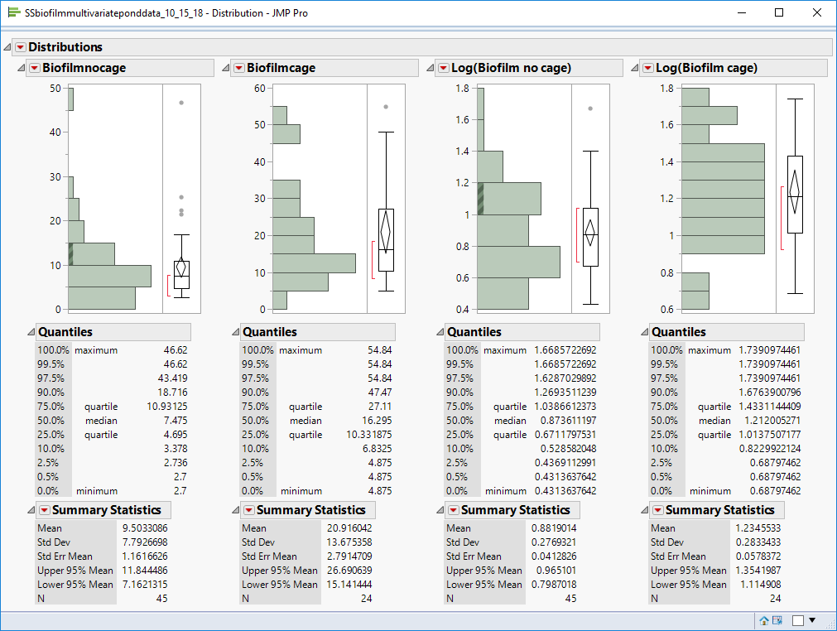

1. Checked distributions of the independent predictors
   * Only Conductivity and Total P are skewed, a log transformation normalizes the data

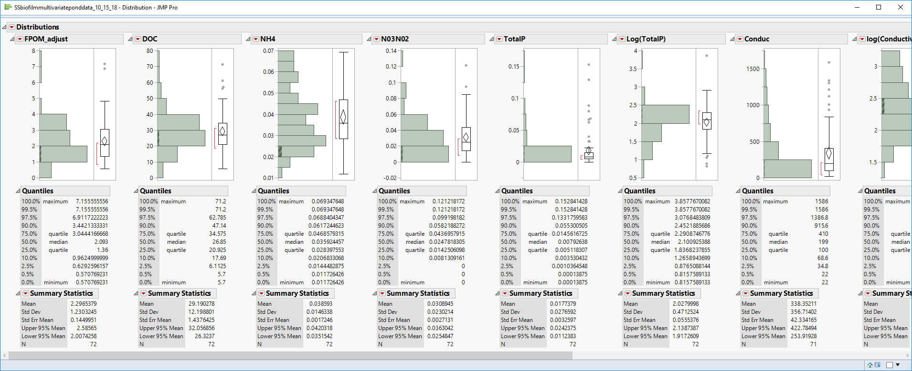

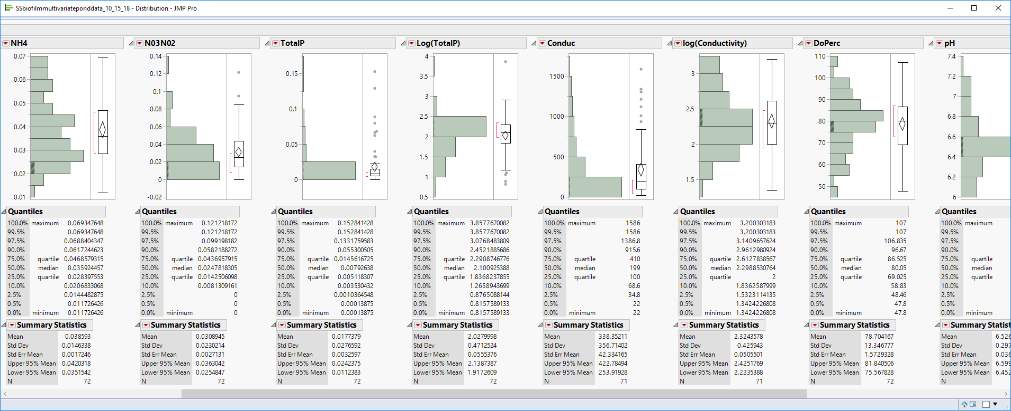

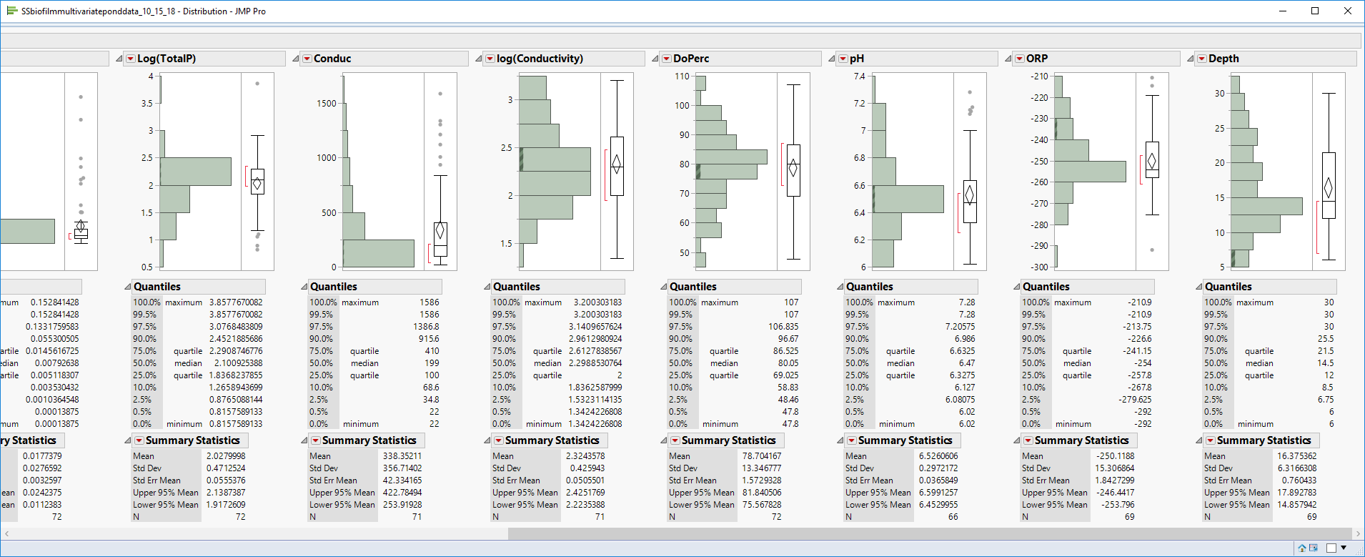

1. Looked at correlations between predictors
   * Several variables are correlated around ~0.3, but not too bad
   * Pay attention to collinearity w/ models

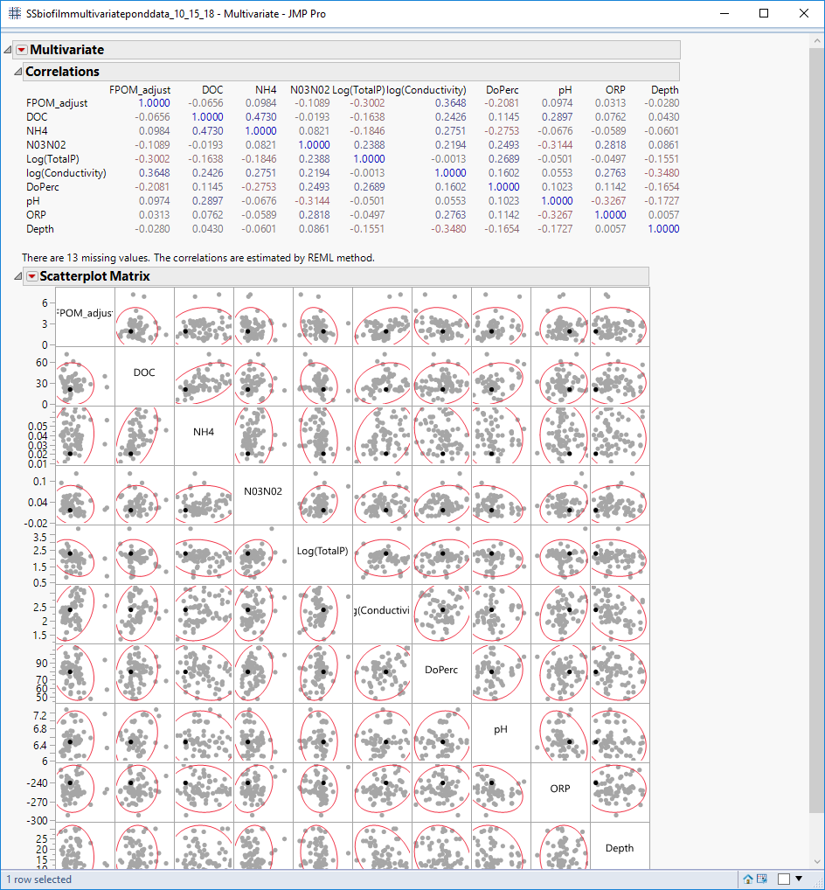

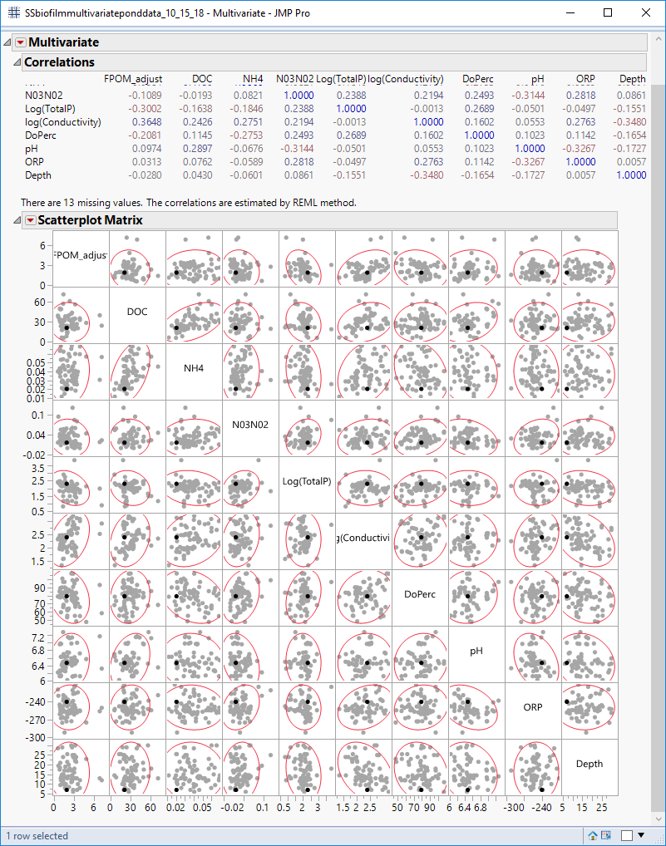

1. Looked at some univariate relationship
   * Lumped together within pond data
   * Nothing jumps out as obvious

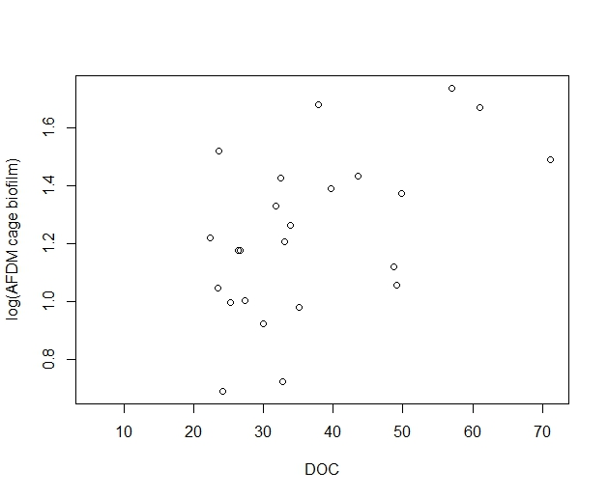 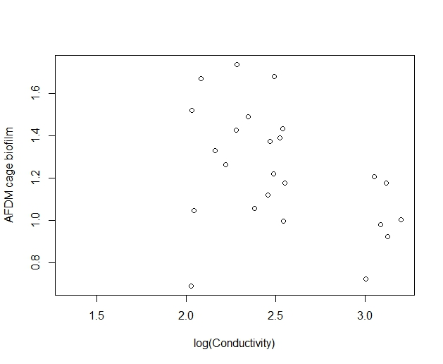

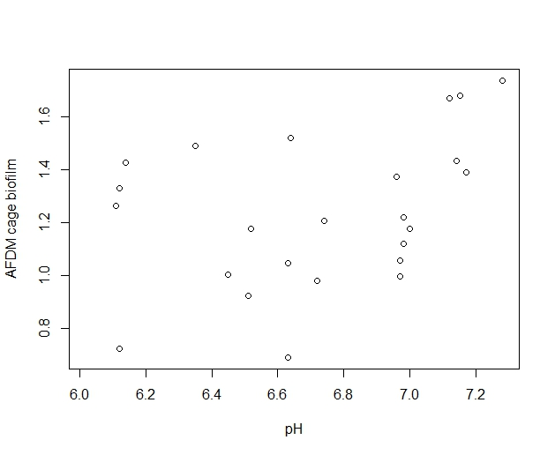 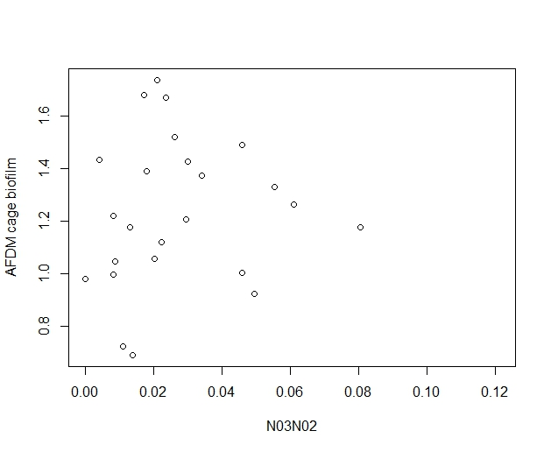

1. Ran a Generalized mixed effects model
   * BiofilmCage~ FPOM+DOC+N03N02+NH4+TotalP+log(Conductivity)+DO+pH+Depth+ (1|Pond)
   * Random effect: Pond, everything else a fixed effect
   * First I scaled the predictor variables
   * Ran the analysis in R and JMP with virtually identical results
   * Random effect (pond) explain only about 6% of variance
   * Significant predictors: NO3/N02, Ph, marginally significant: FPOM

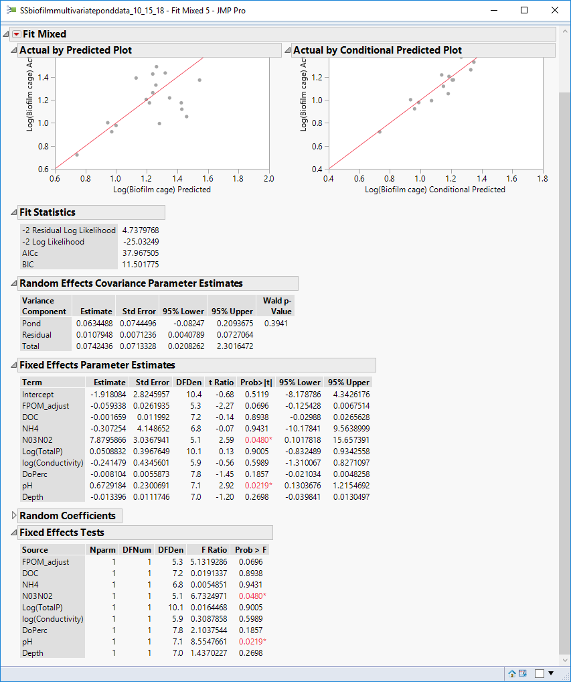

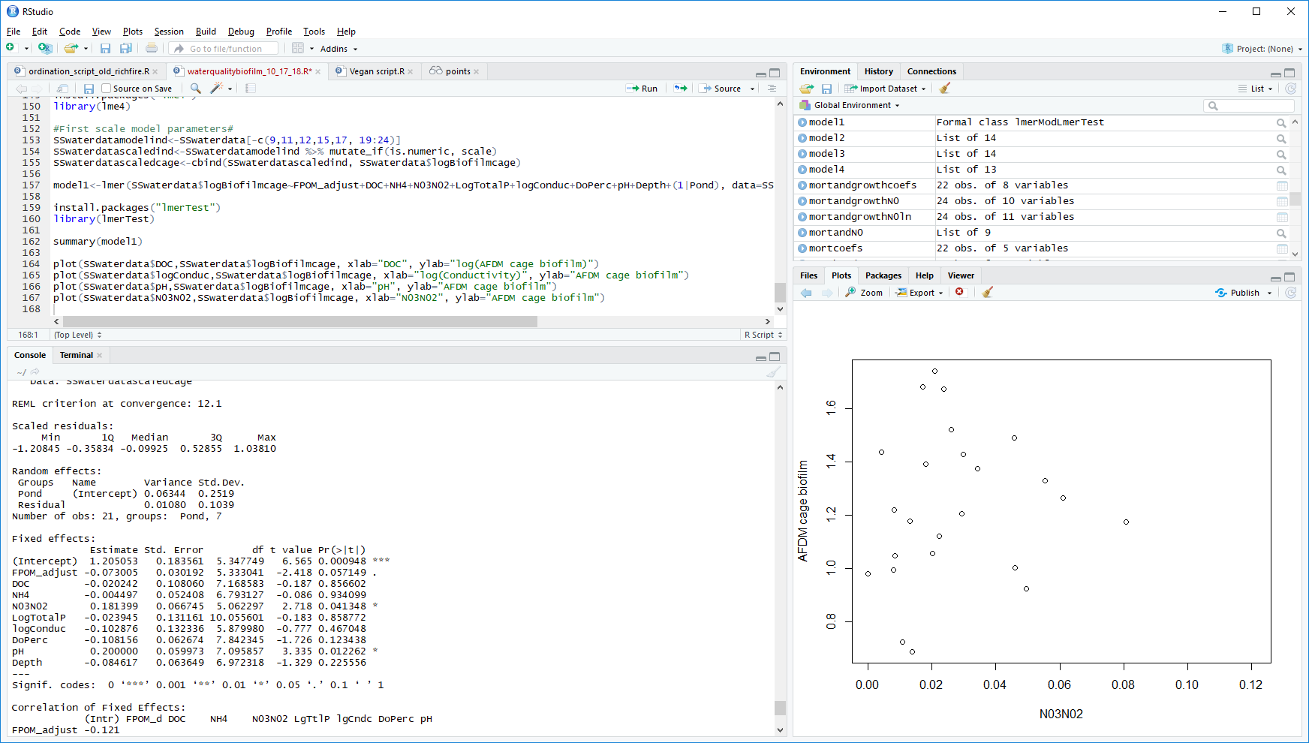

1. Another approach: Try plotting the ponds with a PCA
   * First I separated the data by sampling period
     + 1: first instars
     + 2: 2nd/3rd instars
     + 3: Pupae

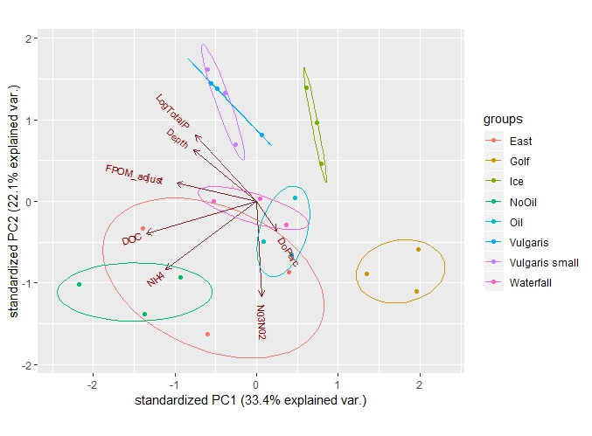

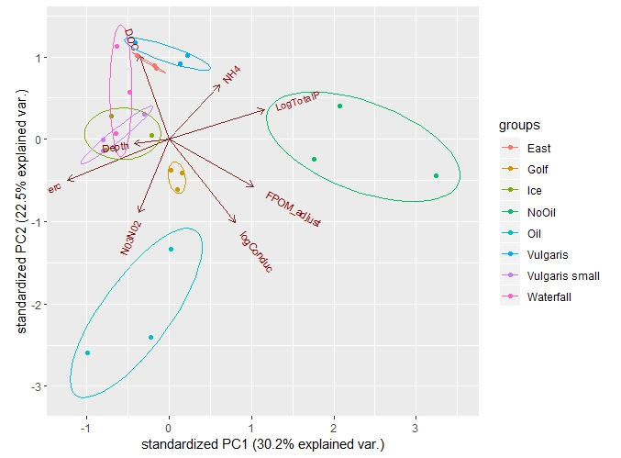

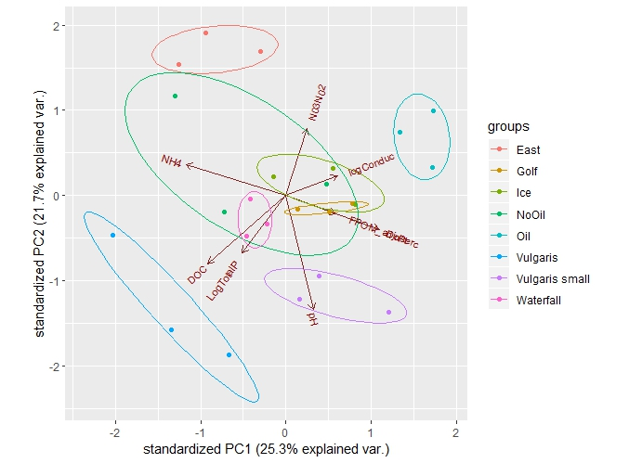

Loadings PCA1

> pcafirst$rotation[,1:5]

PC1 PC2 PC3 PC4 PC5

FPOM_adjust -0.42759308 0.1181530 -0.23252647 0.55081904 -0.54290884

DOC -0.59118069 -0.2127503 0.11923941 -0.04030399 0.27033455

NH4 -0.48549911 -0.4513647 0.01460022 0.12153707 0.29643935

N03N02 0.02703444 -0.6269117 -0.10599727 -0.46570615 -0.61139414

LogTotalP -0.32575982 0.4353970 0.45953963 -0.16217627 -0.39630319

DoPerc 0.10653830 -0.1979161 0.83281922 0.08973390 -0.03826939

Depth -0.33728242 0.3395402 -0.12450013 -0.65495586 0.10940462

Loadings PCA2

> pcasecond$rotation[,1:5]

PC1 PC2 PC3 PC4 PC5

FPOM_adjust 0.4419919 -0.28604781 0.088881262 -0.28035016 0.52700073

DOC -0.1591836 0.51293257 0.391840836 0.03624611 0.57780435

NH4 0.2650457 0.32789468 0.494874695 0.41344943 -0.20375220

N03N02 -0.1557863 -0.44464962 0.538805581 0.32077514 -0.21544842

LogTotalP 0.4975529 0.17913089 0.027329520 -0.28520860 -0.48468786

logConduc 0.3464288 -0.50485032 0.174465934 0.14436144 0.20297179

DoPerc -0.5327379 -0.24938521 0.005313664 -0.05159504 -0.04300012

Depth -0.1827668 -0.02634245 0.521665567 -0.73580342 -0.15003500

Loadings PCA3

> pcapupae$rotation[,1:5]

PC1 PC2 PC3 PC4 PC5

FPOM_adjust 0.2765302 -0.1071492 0.3608814 -0.54080442 0.52054227

DOC -0.4287650 -0.4051587 0.2530227 0.31537012 -0.09926599

NH4 -0.5498180 0.1847799 0.1887413 -0.22248448 -0.29681584

N03N02 0.1182568 0.3984128 0.3646371 0.53743539 0.10512450

LogTotalP -0.2398533 -0.3417148 0.5550167 0.07571274 0.30494049

logConduc 0.2821860 0.1172537 0.5207658 -0.30210708 -0.66139827

DoPerc 0.5137377 -0.2010001 0.1602735 0.41124851 -0.11941423

pH 0.1494062 -0.6786536 -0.1795341 -0.06008068 -0.27447235

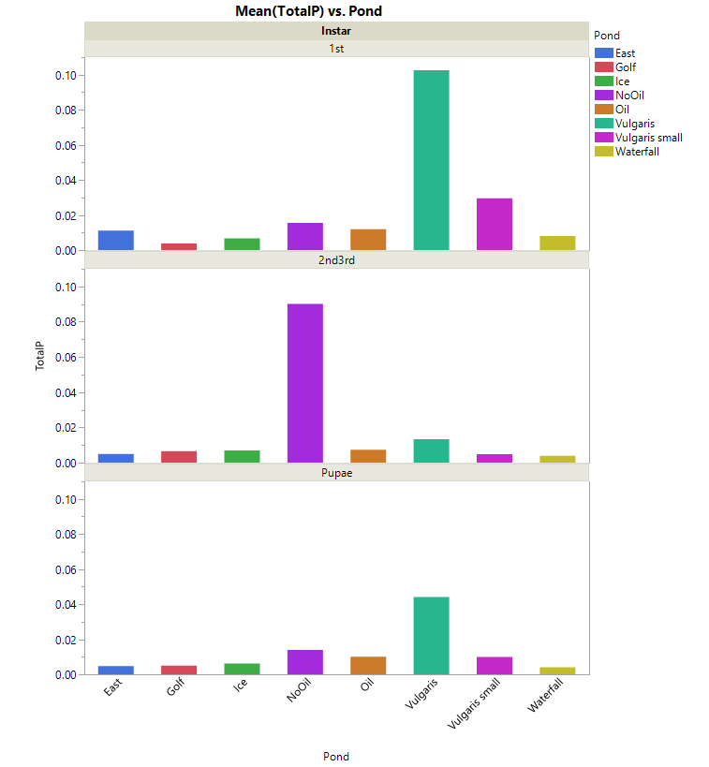

Analysis of Variance Table

Response: LogTotalP

Df Sum Sq Mean Sq F value Pr(>F)

Pond 7 7.4933 1.07047 14.0800 9.139e-10 ***

Instar 2 0.7990 0.39949 5.2545 0.0086383 **

Pond:Instar 14 3.8260 0.27329 3.5946 0.0004577 ***

Residuals 48 3.6493 0.07603

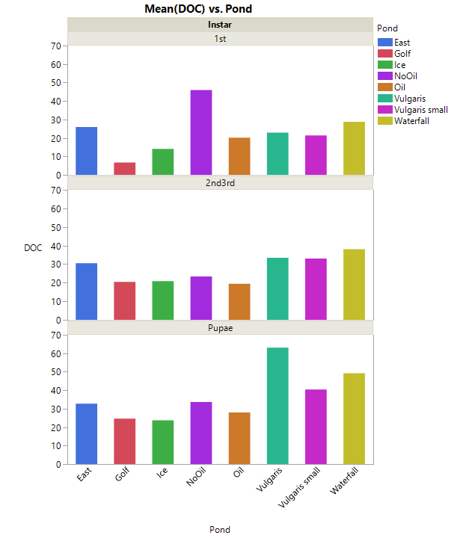

> anova(DOCmodel)

Analysis of Variance Table

Response: DOC

Df Sum Sq Mean Sq F value Pr(>F)

Pond 7 4626.3 660.89 61.168 < 2.2e-16 ***

Instar 2 2354.3 1177.14 108.948 < 2.2e-16 ***

Pond:Instar 14 3066.4 219.03 20.272 1.71e-15 ***

Residuals 48 518.6 10.80

---

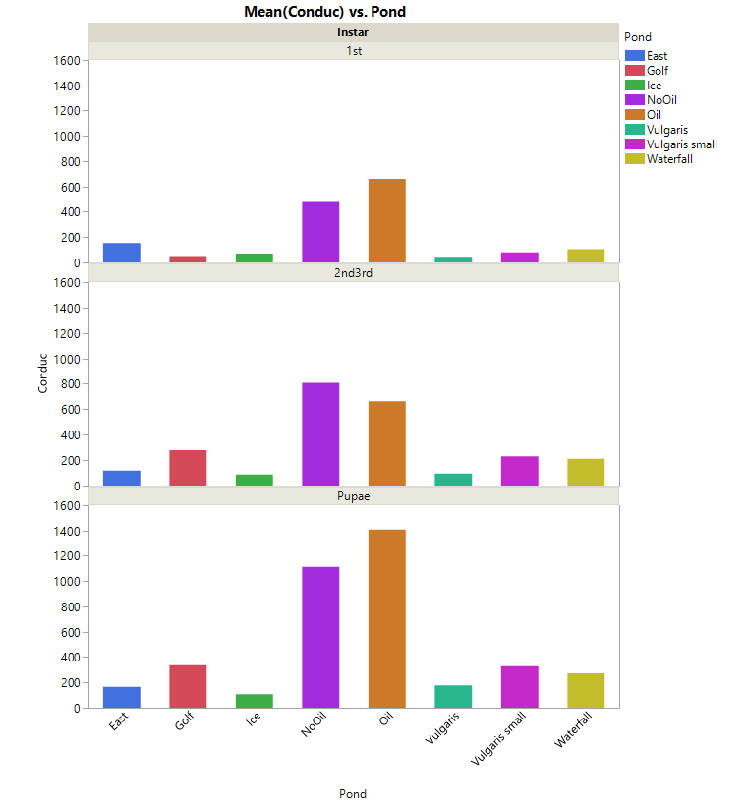

Analysis of Variance Table

Response: logConduc

Df Sum Sq Mean Sq F value Pr(>F)

Pond 7 8.9349 1.27642 151.0416 < 2.2e-16 ***

Instar 2 2.3256 1.16279 137.5963 < 2.2e-16 ***

Pond:Instar 14 1.0422 0.07445 8.8093 6.094e-09 ***

Residuals 47 0.3972 0.00845

---

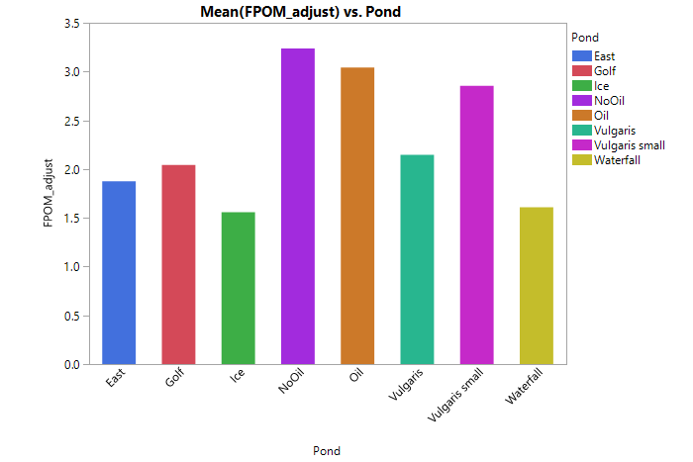

Analysis of Variance Table

Response: FPOM_adjust

Df Sum Sq Mean Sq F value Pr(>F)

Pond 7 27.305 3.9007 3.7129 0.002752 **

Instar 2 5.589 2.7943 2.6598 0.080262 .

Pond:Instar 14 24.151 1.7251 1.6420 0.101731

Residuals 48 50.428 1.0506